Shepherd of the Valley UMC
P. O. Box 1805
Indio, CA 92202


5  10  11  12  19  21 | Linda Shurlow  Amelia Rhodewalt  Travis Nelson  Noel Woodward  Analia Castillo  Cathy Brocker |  | 26  27  29  31 | Janet Rhodewalt  Ken Harris and  Robert Kistler  Barbara Grode and  Julie Kistler  Drew Patterson

 |  | December 2018
 |  | THE DATELINE
Official Newsletter for
Shepherd of the Valley UMC
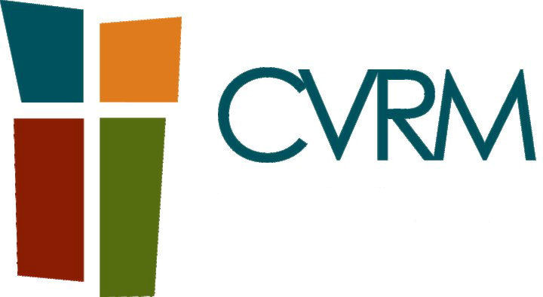 | CVRM Barrel Sunday  December 2nd Narthex.
 | Our All Church Conference Sunday, December 2, 2018
 | Celebrate the Season  Sunday, December 9th.  Please join us for Worship with  Special Music.
Bridge Team | Bridge Team Barrel Sunday  December 16th Narthex.  At the Bridge Saturday December 22nd. Volunteer sign-up sheet is in the Narthex.
 | Mark Your Calendar!  United Methodist Women Annual Bake Sale  Sunday, December 16th  Following Worship
 | Christmas Eve  Candle Light Service  December 24th  7:00 PM
FROM THE PASTOR
By Pastor Lynn

A Season of Thanksgiving …
Can you believe it? We are transitioning into a new season. The weather has gotten cooler (Thank you Jesus!) and the season of Thanksgiving is upon us. Traditionally, we set aside Thanksgiving Day as a time to gather with family and friends and enjoy God’s bounty. It is a time to acknowledge and give thanks for the many blesses we experience throughout the year.
This year I am grateful for all that God has done within our church community. I am most grateful for the work of our Leadership Council and their guidance for the past year. I am excited to see the work that the men’s group is doing in focusing on our mission (To share the love of Jesus Christ with our neighbors in the Coachella Valley) and church growth. I am grateful for the ministry leaders of finance and outreach who are working hard to help us achieve our goals. I am grateful for the Trustees and their team who have been making our church facilities safer and more inviting. I am grateful to our youth who are stepping up and taking leadership roles in worship. I am grateful for the worship team who work behind the scenes to make worship a joy-filled experience. I am thankful for our small group leaders who help us grow to be devoted disciples of Jesus Christ. I am thankful for our music team who work hard to bring us music to enhance our worship. I am grateful for our admin team who do many more things than I could ever list. I am grateful for our hospitality team who feed us and welcome us each Sunday. I am grateful for each one of you and the many things you are doing to share God’s love through your personal ministries. Your efforts really do make a kingdom difference.
Continued on back page
Continued

I am especially grateful for the work of the Holy Spirit in regard to our new focus on Hispanic Ministry. About 70 percent of our neighbors have Hispanic heritage. If we are to make a difference in this neighborhood where God has placed our church it is important for us to reach out to our Hispanic neighbors. Currently we have a Spanish speaking Al-Anon group meeting twice a week. A Spanish speaking worship service/Bible Study on Sunday morning and five Spanish-speaking “house churches” meeting during the week. God is doing something special here and I am grateful that our long-term members have been so kind and welcoming to our newest visitors/members.

As we continue in this Season of Thanksgiving I invite you to give thanks with a grateful l heart and ask for god’s continue blessing for us as we seek to serve the Lord.

Enjoy the journey!
Pastor Lynn

GIFT CARDS
by Bob & Sheila West

Getting ready for your holiday shopping remember for all your shopping and gift giving needs we have a card for you. Please see me in Fellowship Hall after church most Sundays for a complete list of everything available.

FROM THE TRUSTSEES
by Pam Parsons

As you are making your gift list, we have a great suggestion for your family members and friends. We will be installing the same 2’ x 2’ carpet squares in the Narthex and Sanctuary. You can dedicate a square for a twenty-five-dollar donation to the C3 Campaign and you’ll have a win-win gift solution. We hope to have the funding to install the carpet in the New Year.

Merry Christmas from your Trustees!

FROM FINANCE


Shepherd of the Valley
United Methodist Church
Giving Update
Month of October, 2018
Where we need to be: $192,509 (*YTD budget)
Where we are: $185,778 (*YTD giving)
- $6,731
*Year-to-Date September 2018
Good News and Results that Make a Difference: During the month of October, we welcomed 9 new members from multiple families and celebrated 3 baptisms. On October 27th, our Under the Bridge members served 25 homeless men and women, and our growing Hispanic ministry grew by 20% and added 5 “church homes”.
Questions? More Details? Rich Parsons, Finance Chair
FUTURE CAMP INFORMATION

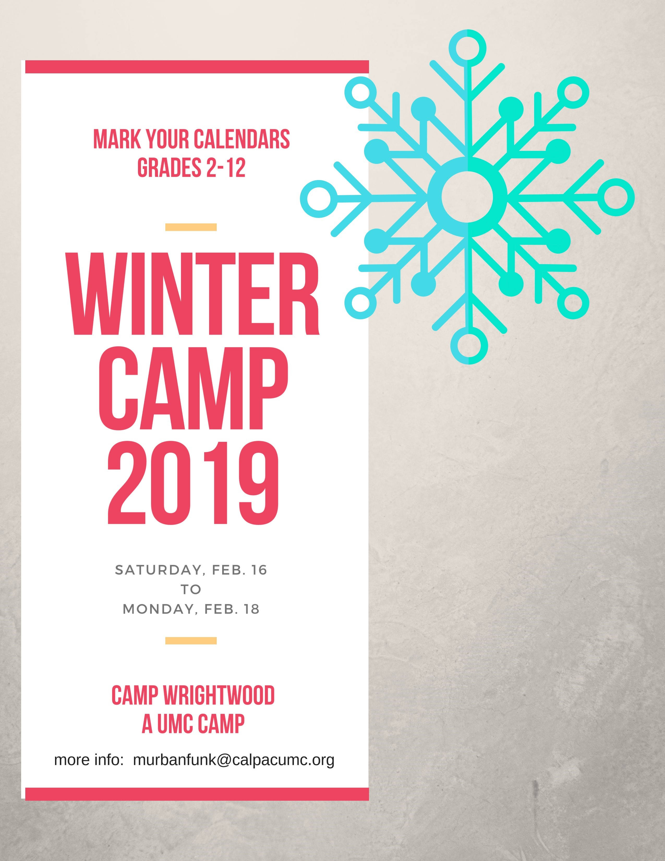

Camp Wrightwood SUMMER CAMP DATES for 2019

GRAND CAMP 6/30 - 7/2
SR HIGH CAMP 7/7 - 7/13
JR HIGH CAMP 7/14 - 7/20
YOUNG ELEM CAMP 7/21 - 7/24
OLDER ELEM 7/21 - 7/26

programs@campwrightwood.com

Registration starts January 1, 2019

THE BRIDGE TEAM

DONATION BARREL:
SUNDAY, December 16th (Third Sunday)
DELIVER TO BRIDGE:
SATURDAY, December 22nd (Fourth Saturday)

Our bridge ministry is going strong. Last month we served 20 people and we had 13 volunteers. Each time we go and serve the homeless, we act as the hands and feet of Jesus. It amazes us how thankful and grateful the individuals truly are. One can see a glimpse of God in the smiles that we see when we hand out the food, water and hygiene products to the individuals at the bridge. The bridge ministry is truly a great opportunity to serve God, the church and those around us who are less fortunate. It is also a great opportunity to let God’s light and love shine to those who may not know God’s Love.
Many thanks for your continued support in helping those in our community less fortunate. Yes, we need peanut butter and jelly sandwiches, water, snacks, fruit cups or fresh fruit, candies, shoes, clothing, tarps, and AA and AAA batteries. Our next visit is on Saturday December 22nd. Please continue in the spirit of giving this holiday season.
if you’re interested in going to the bridge with us please sign up on the volunteer sheet in the Narthex or call Cathy Brocker 760-799-0366.
Thank You and God Bless.
WORSHIP COMMITTEE

Remember, the sign-up sheet is on a clipboard in the Narthex and your help is needed as a greeter, usher, liturgist or coffee host. The next meeting of the Worship Committee will be Friday, December 7th at 10:00AM in the adult classroom.

DISCIPLESHIP MINISTRIES
In January, 2019, there will be opportunities join one of our existing weekly small growth groups or begin in one of the 3 new groups. Openings will exist for 1 or 2 new members in either the Monday or Tuesday (the 10:30am group) morning groups.

So, what are the 3 new small groups? 1) The United Methodist Men just began new weekly small group study on Wednesday morning (See Len Henderson for details). 2) Bud and Marcia Wrisley are planning to begin a new weekly small group for couples. 3) Howard Bolinger will begin and facilitate a new weekly small group that will focus on studying and discussing character traits.

For more information and/or questions on these nurturing and growth opportunities, please contact Howard Bolinger at 760-771-3016 or hlbolinger@verizon.net

OUTREACH COMMITTEE
The Outreach Committee wants to thank the congregation for their donations of “cold weather” clothing. All items were taken to the Coachella Valley Rescue Mission and they were greatly appreciated.

Outreach Opportunities for December 2018
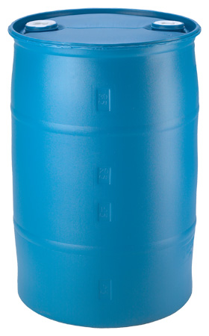 | Blue Barrel 1st Sunday  Nonperishable Food Items  December 2nd.  Narthex  For the Coachella Valley Rescue Mission

 | White Barrel 3rd Sunday  December 16th.  Narthex  For the Bridge

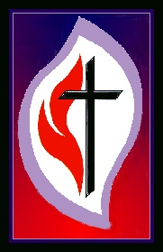
UNITED METHODIST WOMEN
By Margie Schriener, President

We invite you to join us at our next meeting on December 8th at 9AM when we will have our annual installation of officers and our Christmas program.
Our November program was a wonderful inspirational program Erica Stone of SOS – Soldiers Organized Services was our guest speaker.
December 16th following Church is our annual Bake Sale so I assume you have been baking all those goodies that we love so much. Please mark your baked goods and we will price them.
Merry Christmas and Happy New Year!

December, 2018
Please keep in mind the calendar is subject to change.
SUNDAY |  | MONDAY | TUESDAY |  | WEDNESDAY | THURSDAY | FRIDAY | SATURDAY
 |  |  |  |  |  |  |  | 1
Communion Sunday | 2 | 3 | 4 |  | 5 | 6 | 7 | 8
8:20 AM Choir Rehearsal  9:00 AM Sunday School  10:00 AM Worship  11:15 AM Coffee Fellowship |  | 10:30 AM Son Reflectors  7:00 PM Al Anon Spanish | 10:00 AM Growth &  Support Group  10:30 AM Growth &  Support Group  6:00 PM Bell Choir |  | 7:00 AM Men’s Bible  Study  9:00 AM Prayer & Care  Group  6:00 PM Community Bible Study  7:00 PM Al Anon Spanish | .  5:00 PM UMW Board Mtg. | 10:00 AM Worship Cmte. | 9:00 AM UMW Unit Mtg.
 | 9 | 10 | 11 |  | 12 | 13 | 14 | 15
8:20 AM Choir Rehearsal  9:00 AM Sunday School  10:00 AM Worship  11:15 AM Coffee Fellowship |  | 10:30 AM Son Reflectors  7:00 PM Al Anon Spanish | 10:00 AM Growth &  Support Group  10:30 AM Growth &  Support Group  6:00 PM Bell Choir |  | 7:00 AM Men’s Bible  Study  9:00 AM Prayer & Care  Group  6:00 PM Community Bible Study  7:00 PM Al Anon Spanish
 | 16 | 17 | 18 |  | 19 | 20 | 21 | 22
8:20 AM Choir Rehearsal  9:00 AM Sunday School  10:00 AM Worship  11:15 AM UMW Bake Sale |  | 10:30 AM Son Reflectors  7:00 PM Al Anon Spanish | 10:00 AM Growth &  Support Group  10:30 AM Growth &  Support Group  6:00 PM Bell Choir  6:00 PM Boy Scout Troop #  1701 |  | 7:00 AM Men’s Bible  Study  9:00 AM Prayer & Care  Group  6:00 PM Community Bible Study  7:00 PM Al Anon Spanish |  |  | 7:30 AM Go to the Bridge
 | 23 | Christmas Eve 24 | 25 |  | 26 | 27 | 28 | 29
8:20 AM Choir Rehearsal  9:00 AM Sunday School  10:00 AM Worship  11:15 Coffee Fellowship  11:30 AM Leadership Council |  | 10:30 AM Son Reflectors  7:00 PM Candle Light  Service  7:00 PM Al Anon Spanish | 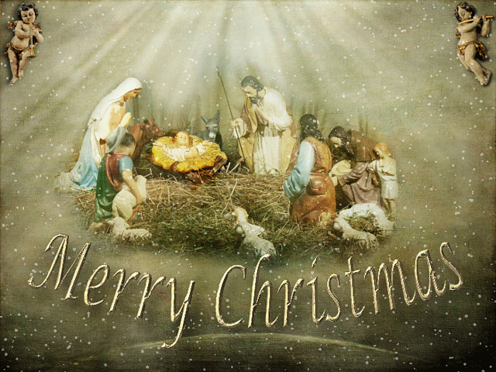 |  | 7:00 AM Men’s Bible  Study  9:00 AM Prayer & Care  Group  6:00 PM Community Bible Study  7:00 PM Al Anon Spanish
30 |  | New Year’s Eve 31
8:20 AM Choir Rehearsal  9:00 AM Sunday School  10:00 AM Worship  11:15 AM Coffee Fellowship |  | 10:30 AM Son Reflectors  7:00 PM Al Anon Spanish

